Project Description
Time Difference of Arrival (TDOA) Experiment
Audio Waveform Optimization
November 1, 2024
Steve Cerwin WA5FRF
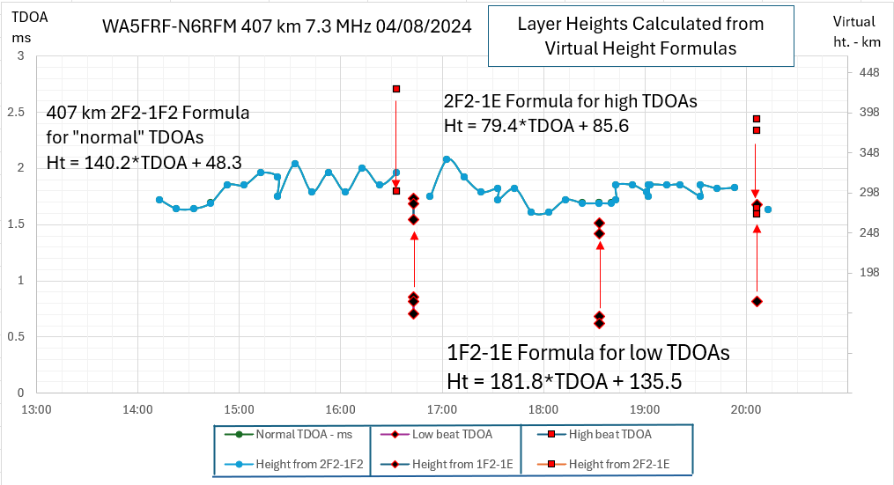

Figure 1. TDOA Analysis Identified Multiple Propagation Modes and Measured F2 Layer Height During 2024 Total Eclipse
- Introduction and Background
An ongoing HamSCI science objective is to use ordinary amateur radio stations to sense and quantify how HF radio waves propagate through the ionosphere. Parameters of interest include determining which ionospheric layers are involved over an arbitrary propagation path, the height of the layers involved (particularly the F2 layer), and how these change in response to solar events such as dawn, dusk, solar flares, coronal mass ejections, and eclipses.
Two methods developed previously and shown capable of detecting a height change in the F2 layer used transmissions from standard time and frequency station WWV. These were Time of Flight (TOF) measurements facilitated by the WWV per-second timing ticks and a mathematical analysis of Doppler shifts observed on the carrier frequency. Both techniques demonstrated success in detecting the height changes in the F2 layer that occur every morning and evening in response to waxing and waning sunlight. The Doppler technique additionally used WWV Doppler data to profile a bump in F2 layer height during the 2017 eclipse. These techniques required the extreme timing and frequency precision built into the WWV transmitter and receiver calibration disciplined by the addition of a GPS Disciplined Oscillator (GPSDO). This level of equipment sophistication was considered beyond that desired for the widespread accessibility desired for commonplace radio installations. The techniques also were geographically constrained because of the requirement to use WWV as a signal source.
More recently, these science objectives have been accomplished by the development of a Time Difference of Arrival measurement technique. The TDOA method derives propagation path and layer height data by measuring the difference in arrival time of multipath modes between any two amateur radio stations. Consider, for example, multipath reception comprised of 1 and 2 hops from the F2 layer. Because the 1-hop mode is shorter than the 2-hop mode it arrives at the receiver first, followed by the two-hop mode after a time delay. The signals from both modes add or superimpose in the receiver. If the ground distance between stations is known and a suitable virtual height or ray trace model of the ionosphere is used, measurement of the time delay between the two arrival times (TDOA) can be used to infer the height of the common ionospheric layer. If plotted as a function of time the method can profile layer height changes over time. This is much easier than the far more difficult task of making absolute time and frequency measurements and can be accomplished with common unmodified amateur radios. Data taken during the 2023 and 2024 eclipses demonstrated the ability to untangle multiple propagation modes and yielded height data in excellent agreement with ionosonde ground truth data.
Measurement of TDOA can be accomplished by transmitting audio waveforms that are sensitive to a time displacement when summed. Three waveforms studied previously were short 1-cycle pulses, linear audio chirps, and pseudorandom noise bursts. The only equipment required to perform the tests was ordinary amateur radio SSB transceivers and computers with sound cards. Additional detailed background information is presented in the Appendices below.
- Project Objectives
The objective of this project is to investigate additional audio waveforms for TDOA measurements. The goal is to develop waveforms that can be used by the amateur radio community to accurately measure the time difference of arrival between multipath propagation modes. While professional ionosonde equipment and trained engineers perform these types of measurements routinely, the requirement to use amateur radios and operators in compliance with federal regulations places constraints on waveform characteristics and processing methods. The project deliverable is an effective waveform optimized for the amateur radio operating environment. It is anticipated that the waveform may be a derivative of those used in the sonar and radar communities that exhibit low sidelobes when processed by a correlation technique.
A major technical issue is the requirement for the waveform to operate within the communications channel audio bandwidth available in amateur Single Side Band (SSB) radios, typically 100-300 Hz on the low end and 2900-3300 Hz on the high frequency end of the passband. The waveform must also be tolerant to nonuniformities in passband shape.
Excellent results were obtained with the linear frequency chirps during the 2023 and 2024 eclipses that gave good correlation with ionosonde hmF2 data. While eclipse related modifications to propagation in the form of layer height bumps and chaotic mode swapping indeed were detected, propagation under less than serene or optimal conditions highlighted limitations that might be overcome by more sophisticated waveforms.
- Previous Work
Three waveforms previously used were 1) short 1-cycle audio pulses centered in the audio passband, 2) a linear audio chirp, and 3) an analog pseudorandom code sequence.
3a. The TDOA measurement using the short pulses was accomplished using the calibrated time scale on the received .wav file. The multipath time delay results in two or more pulses separated along the time axis. The TDOA value was obtained by measuring the time difference between matching parts of received pulses. The pulses served as an immediate and intuitively satisfying indication of multipath. The main drawback of the short pulses was waveform distortions and ringing induced by the audio characteristics of the transmitter and receiver. Because of this they were used mainly as backup and as verification that multipath was present.
3b. A TDOA measurement using a linear audio frequency chirp can be accomplished by several means including a visual analysis of the .wav file. The simultaneous presence of a chirp waveform with a delayed copy of itself produces a beat note at a frequency that is equal to the product of the sweep rate and the time delay. The beat note visibly manifests itself as amplitude scalloping on the composite chirp envelope. Figure 2 illustrates an example generated by summing two 100 Hz/ms linear sweeps with a 1 ms time delay. The calculated beat note is 1 ms * 100 Hz/ms = 100 Hz. Figure 2a shows the stereo .wav file containing these two chirps. The bottom sweep was also reduced in amplitude to more accurately simulate the amplitude difference expected between 1 and 2 hop signals. Figure 2b shows the electronic sum exhibiting the 100 Hz beat note. If the period p of the beat note is measured between adjacent nulls, TDOA can be calculated from 1/(p*SR) to yield the 1 ms time difference. TDOA can also be calculated from beat note frequency analysis and by correlation techniques.
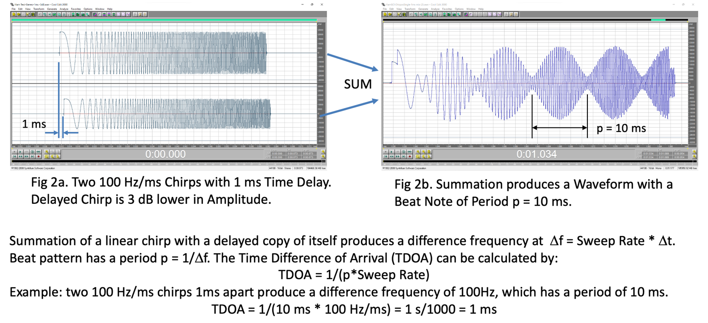
Both external reference (cross) correlation and self-correlation (autocorrelation) processing techniques were used to analyze the chirps. Good agreement was obtained across all techniques.
Figure 2 Use of an Audio Chirp to Sense Time Difference of Arrival
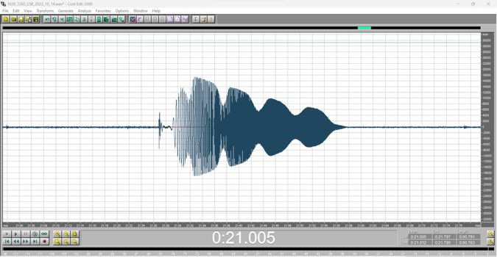
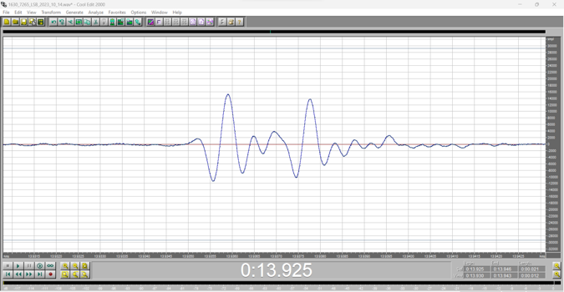
Figure 3 shows examples of short pulse and chirp waveforms received during the 2023 Annular Eclipse. The path was Near Vertical Incidence Skywave (NVIS) over a 9 km ground distance. The NVIS path is interesting because it is operationally equivalent to an amateur radio vertical ionosonde. The waveforms decode to a TDOA of 1.6 ms. Additional examples are in Appendix 3.
Figure 3. 7.2 MHz NVIS TDOA Waveforms. Left: short pulses with time separation. Right: linear chirp with multipath modulation

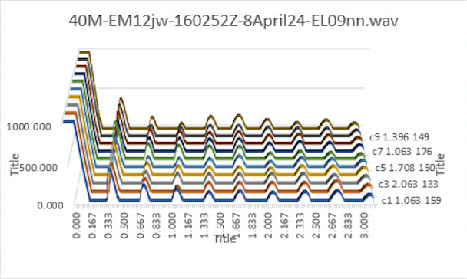
Problems were encountered with the chirps when more than one multipath mode was present at the same time. The frequency domain processing using an FFT on the envelope waveform did better separating the different beat notes than a period analysis using the waveform nulls. A larger problem was encountered when the chirps were analyzed using correlation techniques. This type of waveform is prone to generating correlator ringing, or sidelobes that continue in time after a strong correlation peak as illustrated in Figure 4. These interfere with subsequent correlations and can completely mask weaker responses. Development of a waveform for correlation processing with low sidelobe characteristics is the main objective of this project.
Figure 4. Autocorrelation on Chirp Waveform with Excessive Correlator Ringing (Sidelobes).
3c. A pseudorandom noise burst was included in the TDOA waveforms used during the eclipses. This analog waveform was about 2 seconds long and based on a pseudorandom code that did not repeat along its entire length. The computer-generated waveform had more bandwidth than would fit through the radio passbands so actual occupied bandwidth was radio dependent. Although it met with some success it did not work as well as the chirps.
- Desired TDOA Waveform
The desired outcome of this project is a waveform that can resolve TDOA values with high precision and produce low sidelobes that could interfere with multiple returns. Tom McMahan K1FR, who has a background in radar, suggested a waveform development study during preparation efforts for the 2023 eclipse. However, time constraints preparing for the 2023 and 2024 eclipses precluded development at that time. The three waveforms listed above were deployed for the eclipses. Recently David Kazdan AD8Y suggested use of a Costas Array waveform for this application. A Costas code waveform was first described in 1965 by John P. Costas and is waveform that encodes in both the time and frequency domains. The waveform was conceived as a means of improving the performance of radar and sonar systems. It is suggested that development of the TDOA waveform begin here. An online introduction can be found at:
Costas Code - Radartutorial
The anticipated modulation mode is Single Side Band (SSB). With this mode it is common for the transmitter and receiver to be on slightly different frequencies, perhaps as much as 200 Hz. Therefore, the received waveform might be up to this amount offset in frequency from the transmitted waveform. The chirps used previously suffered no ill effects from an offset because it occurred on both multipath chirps, and it is only their difference that matters. A TX-RX frequency misalignment in chirp waveforms results in only a time shift of the resultant sum waveform.
Amplitude Modulation (AM) is immune to small frequency misalignments, but this mode produces significantly poorer signal to noise ratios compared to SSB. While most 100-watt SSB amateur radios have an AM mode, the peak envelope power the transmitter can output is still only 100 watts. For this reason, most radios output only 25 watts of carrier power.
Requirements:
- Development of an audio waveform that can be transmitted and received by ordinary amateur radios for TDOA analysis in the HF spectrum.
- Desirable properties are high precision TDOA measurements and freedom from sidelobe interference.
- The waveform must be tolerant of variations in the shape and width of the audio passbands commonly found in amateur radios.
- For best signal-to-noise performance the preferred radio modulation is SSB. This mode often results in a frequency shift in the received waveform if the transmitter and receiver are not on the same frequency. The new waveform must either accommodate a frequency shift or use a different modulation scheme.
- The Federal Communications Commission prohibits transmission of encrypted signals in amateur radio bands. The waveform developed in this effort must comply with these regulations. This requirement has been satisfied in the past with some digital communications modes by making the decryption key public.
- The legacy short pulse and chirp waveforms are to be retained. Therefore, the final waveform will be a composite containing sequences of short pulses, chirps, and the new waveform(s).

Appendices

Additional Background Information

Appendix 1. Time Difference of Arrival Analysis for Layer Height Estimation
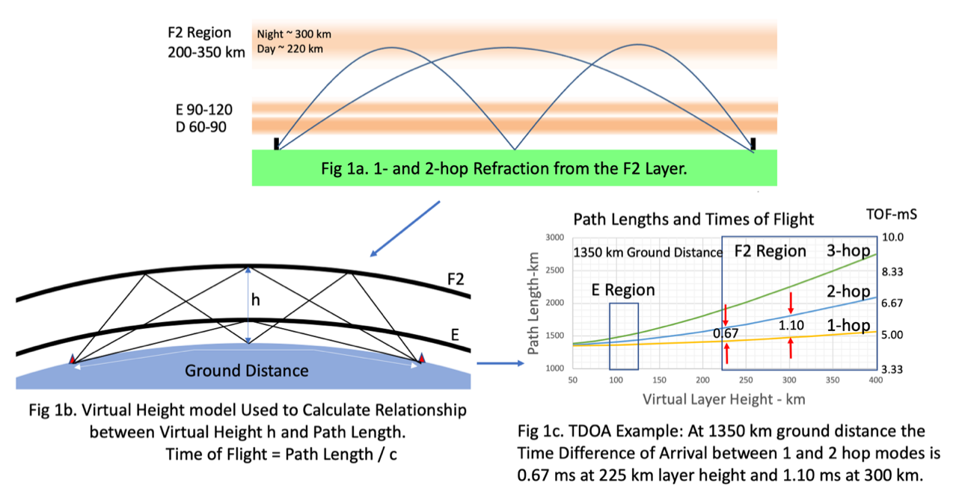
Over propagation paths that support transmission of multiple hops, the Time Difference of Arrival (TDOA) between multipath modes can be used to infer layer height. The focus in this discussion is the 1- and 2- hop mode (2F2-1F2) from the F2 layer because they frequently occur and yield straightforward F2 height calculation. Combinational modes involving the E layer have also been observed (1F2-1E and 2F2-1E). For a given TX-RX path, the arrival times for multiple hops from a common ionization layer are geometrically bound by ground distance, layer height, and hop geometry. Figure 1a illustrates this relationship in a generalized sketch of ionospheric refraction from the F2 layer. Refraction is what occurs, but analysis is complicated because the rays take curved paths, the depth of penetration into the layer is affected by several variables, and wave velocity changes with layer height. Decades ago, it was recognized that a very good approximation could be had by assuming wave speed is constant and the wave returns to earth by straight-line reflection from an equivalent or virtual height.
Figure 2 Formulas Derived from a Virtual Height Model of Multipath Ionospheric Propagation Used to Approximate Layer Height from 1-hop/2-hop Time Difference of Arrival (TDOA)
Figure 1b shows the virtual height model where the curved refraction paths are replaced with straight lines using point reflections. The virtual height model facilitates calculation of path lengths and times of flight from ground distance and layer height using straightforward trigonometry. Figure 1c shows results of path length and time of flight calculations for a ground distance of 1350 km as a function of F2 layer height. As shown by the two examples in Figure 1c, a 1 hop – 2 hop TDOA measurement can be used to infer effective layer height without the need for an absolute TOF measurement. For a 1350 km ground distance the 1 hop – 2 hop TDOA from the F2 region is 0.67 ms for a 225 km layer height and 1.10 ms at 300 km. Recent experiments using this model have shown the approximation afforded by the virtual height model gives excellent agreement with hmF2 ionosonde data and has shown to be adequate for present HamSCI objectives.
Appendix 2. Beat Note Extraction from Chirp Data
One property of a linear frequency chirp exploited with the TDOA method is the fixed frequency beat note that arises from summing two chirps with a time displacement. The beat note generated by summing time-displaced linear chirps produces an envelope shape which has the same characteristics as summing two same-frequency tones with a sliding phase shift. The envelope amplitude of two equal amplitude and frequency sine waves of unit amplitude as a function of phase shift is given by
Envelope Amplitude = sqrt (2 + 2cos (Phi)), where Phi is the relative phase shift.
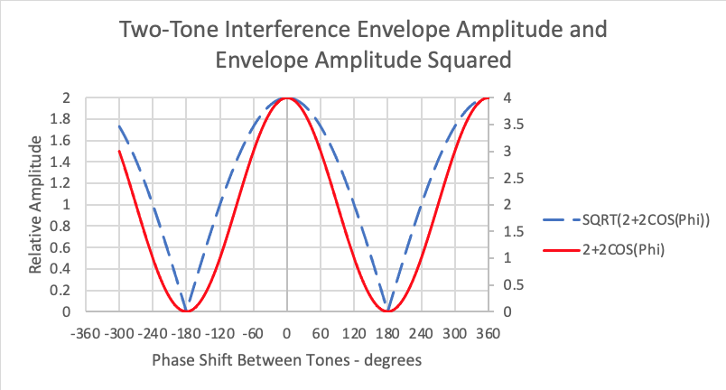
The waveshape has a rounded, constructive interference maximum where the waves are in phase but shows an abrupt straight-sided V at the bottom of the null at 180-degree phase shift. As suggested by the above equation a sinusoidal waveshape can be obtained by squaring the function. Figure 2a is a graphical representation of Envelope Amplitude (dashed blue line) and Envelope Amplitude squared (solid red line). The squaring function yields a unipolar sine wave from which frequency can be measured. A squaring step is a part of the data analysis for this reason.
Figure 2a. The Envelope Amplitude of Two-Tone Interference can be Converted to a sine Wave by Squaring the Waveform
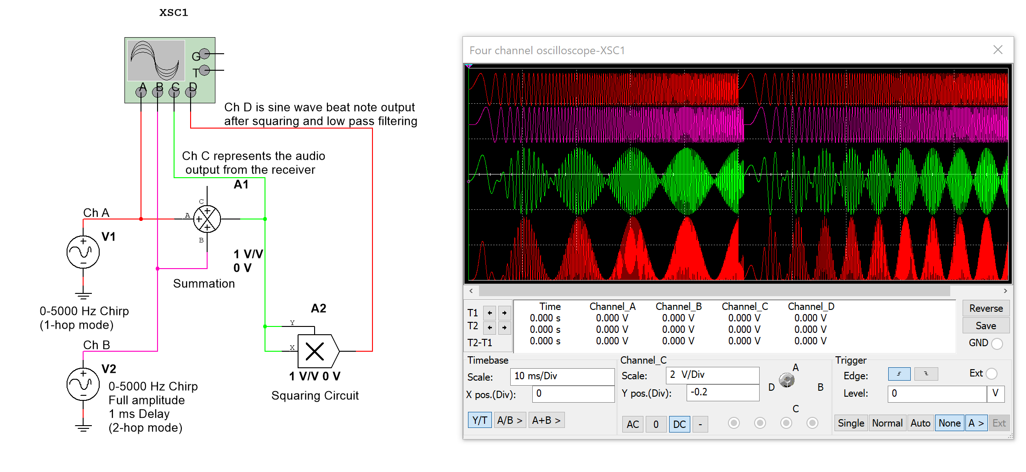
When two linear frequency chirps are summed with a time delay, the waveform has a bipolar envelope shape like the dashed blue line of Figure 2a. Figure 2b is a Multisim simulation of the entire process. On the left is a block diagram showing the function blocks of the simulation. These are two 0-5000 Hz chirp sources, a summation block, a squaring block, and a four-channel oscilloscope. The simulation execution is shown on the oscilloscope display on the right. Two executions are run: a 1 ms time delay on the left half followed by a 2 ms time delay on the right. The top two traces are the time displaced frequency chirps that represent multipath propagation modes. The third trace is their sum showing the same envelope shape characteristics as the Envelope Amplitude of Figure 2a. The sum function represents the natural summing of the two propagation modes in the receiver. The bottom trace is this waveform squared showing a unipolar waveform with an elevated sinusoidal amplitude variation. An envelope detection of this waveform would yield the desired beat note sine wave with a positive DC offset. A zero-average of the sine wave would then give a bipolar sine wave from which frequency could obtained by FFT.
Figure 2b. Multisim Simulation of the Addition of Time Delayed Linear Chirps and Squaring their Sum to Obtain a Sinusoidal Beat Note Pattern.

Appendix 3. TDOA Data Examples
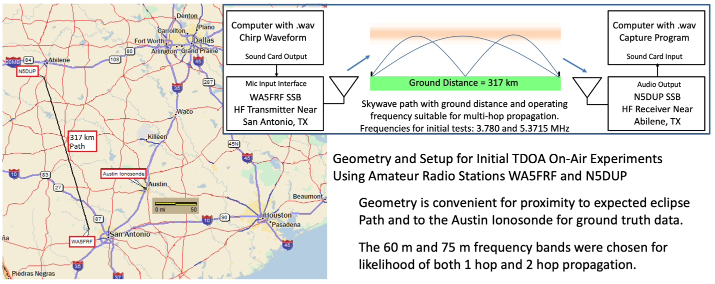
A preliminary test of short pulse and chirp TDOA measurements was conducted between amateur radio stations WA5FRF and N5DUP in Texas prior to the 2023 eclipse. Figure 3 gives a map showing the 317 km propagation path and orientation with respect to the Austin ionosonde. The ionosonde was used as an independent height measurement for comparison purposes (ground truth). Test frequencies of 3.780 MHz and 5.3175 MHz were chosen to maximize probability of simultaneous 1 and 2 hop modes. Frequencies used during the eclipse were 5.3 and 7.3 MHz because the 3.8 MHz (80 meter) band would be closed at eclipse time.
Figure 3 Setup for On-Air TDOA Measurements between Amateur Radio Stations WA5FRF and N5DUP.

Figure 4a shows examples of the received short pulse and chirp waveforms. The short pulse TDOA was measured directly from the .wav file by measuring the time difference between like points on the primary and delayed pulses. TDOA from the chirp was calculated by first measuring the time delay between adjacent nulls to get the period of the two-tone beat note. The TDOA then was calculated from TDOA = 1/(period * Sweep Rate). Both the chirp and short pulse data indicated a TDOA of 1.6 ms.
The family of curves shown in Figure 4b was calculated from a spreadsheet developed from the virtual height model. It converts TDOA to layer height for ground distances from 250 to 3000 km. A virtual layer height of 270 km was calculated for the 317 km ground distance and 1.6 ms TDOA. The average and spread of all data points for the time and day of the tests are overlaid on the Austin ionosonde hmF2 plots in Figure 4c. The TDOA method gave layer height data reasonably consistent with the ionosonde. Subsequent data obtained during the 2024 total eclipse gave excellent agreement with ionosonde hmF2 data as shown in Figure 5.

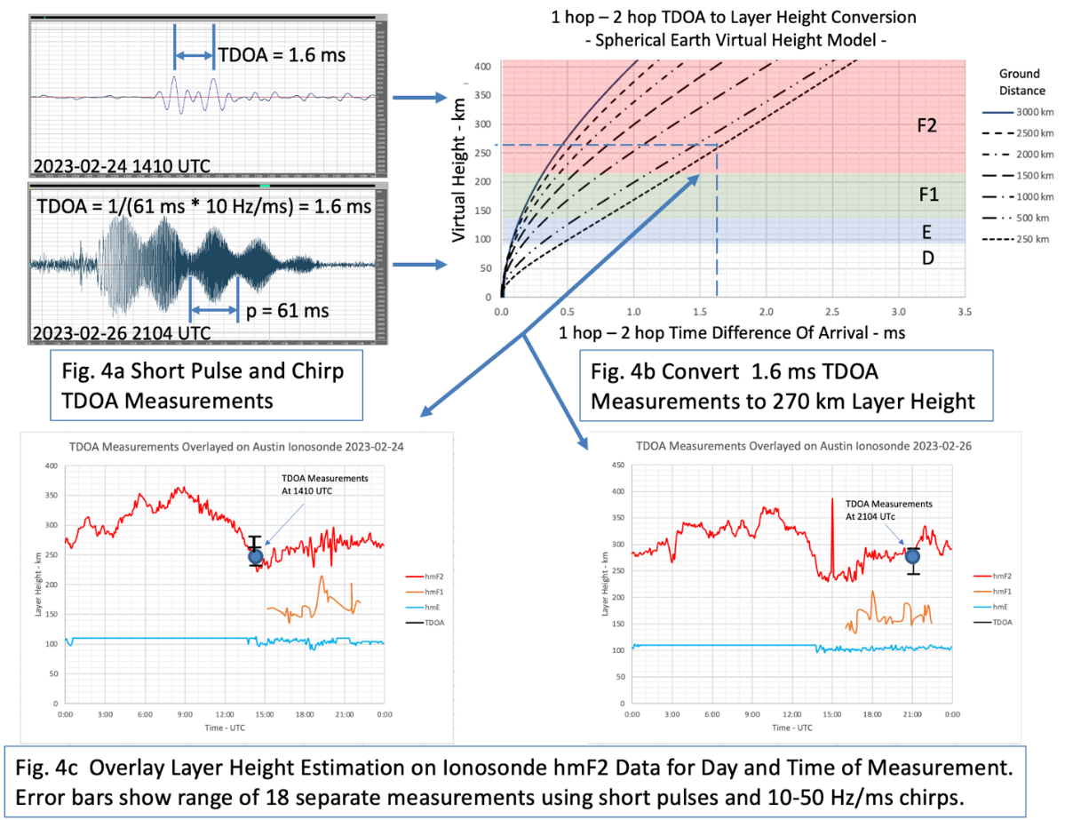

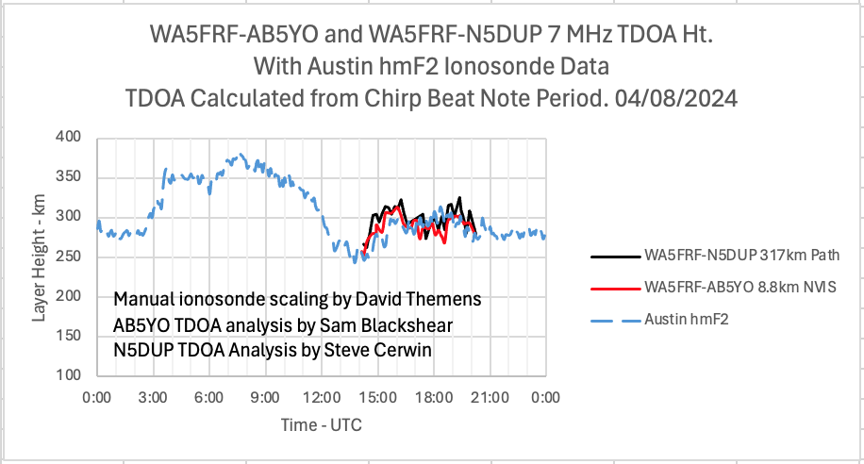
3 Fig 5. F2 Layer Height Calculated from TDOA Data Overlaid on Ionosonde hmF2 Data
Figure 4. Results of the Texas On-the-Air TDOA Tests were Consistent with Austin Ionosonde hmF2 Data.
Appendix 4. Mechanisms that Could Cause Degradations to Accuracy with Short Pulses and Chirps
- Multipath propagation between modes that are not 1-hop 2-hop related will give inaccurate height data unless the correct formula for the mode or combinational mode is used. The TDOA waveforms must first be vetted for likely mode structure and adequate signal to noise ratio prior to layer height estimation.
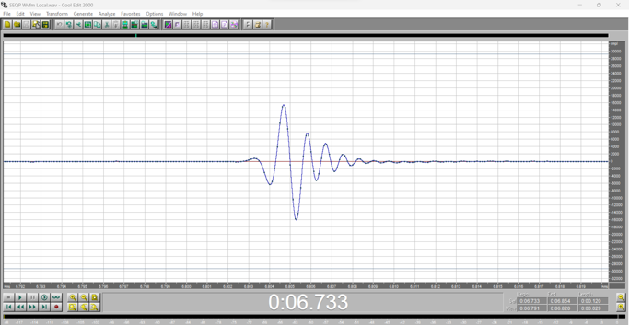
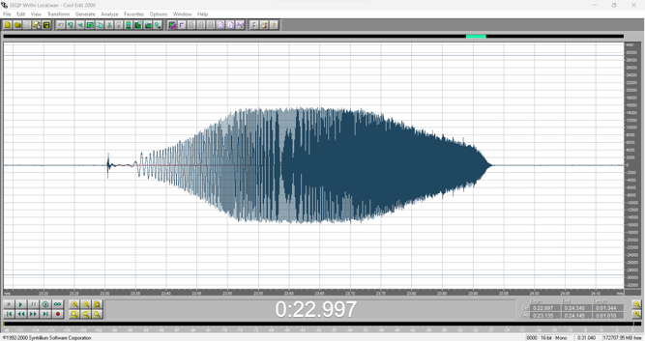
- Distortions to 1 cycle pulse waveshape and chirp envelope amplitude from equipment audio characteristics affect overall envelope shape. Figure 6 shows the appearance of the 1-cycle pulse and a chirp over a short transmission distance without multipath. The audio circuitry in this receiver added ringing to the pulse and the combined audio passbands changed the shape of the chirp envelope by restricting low and high frequency response. The ringing in the 1-cycle pulse adds to the pulse of a delayed version causing visible distortion. The change in the chirp envelope shape is largely inconsequential since it is the frequency of the beat note that is of interest. But restrictions in the total available bandwidth limit the range over which the chirp can span, and this shortens the number of cycles in the beat note available for analysis.
Figure 6. Appearance of Short Pulse and Chirp Data in a Short-Range Transmission Path Free from Multipath

- Differential Doppler shifts between 1- and 2- hop modes can profoundly affect accuracy of the TDOA measurement under times of rapidly changing layer height. The 2-hop mode incurs more Doppler shift than the 1-hop mode, upsetting the frequency difference between the chirps caused by time delay. The extra Doppler in the 2-hop mode alters both pitch and chirp length. This results in the second chirp having a different sweep rate from the first. The result is a beat note on the wrong frequency that also changes frequency over chirp length.
- There is no degradation from minor frequency differences in calibration between SSB transmitter and receiver. The multipath interference between the two modes is fixed when they appear in the receiver input. If the SSB receiver is off frequency, the frequency error appears identically on both chirps. So the frequency of the entire superposition can move up or down (producing a time shift in the sum) but the difference between the chirps and therefore the beat note is unaffected. If the frequency error is severe the length of the chirp superposition will be reduced because of the mismatch in audio passbands.

Project Requirements

Project Objective
The objective of this project is to develop a DSP code that at minimum accomplishes the analysis described in Section 8: Data Extraction and Display. The code and results must be written up into a report as described below. Your project will be graded using the rubric posted on Brightspace. Please read this rubric carefully before starting your project.

Code Requirements
It is recommended that you use a python-based Jupyter Lab notebook for this assignment. It is expected that the code will run without errors or modification on the instructor’s machine. Be sure to test your code thoroughly before submission. Code should be well-developed, modularized, and documented.
Starting code for this project has been developed for you and is available at https://github.com/w2naf/wa5frf_chirp_analysis as Chirp Analysis.ipynb. You are welcome to use this code as a starting point for your project. You should enhance it and build on it as needed, and be able to explain its functionality in the methodology part of your report.

Paper Format
Each team must produce a written report explaining their findings and documenting their methodology, results, and code. Papers should use a standard IEEE conference paper format. An appropriate Overleaf template is available from https://www.overleaf.com/latex/templates/ieee-conference-template/grfzhhncsfqn.
Papers should include the following:
- Title
- Abstract (350 Words or Less)
- Author Name
- Introduction
- Methodology
- Results
- Discussion
- Conclusion
- Acknowledgements
- References
Subsections are allowed. You should have figures/tables in your paper to support your work. Your methodology should include not only a description of how your code works, but also your testing procedure. Acknowledgements should include any source of help you had in developing the code, as well as any source of data used.

Project Submission and Due Date
Submit your project to the Brightspace Dropbox by 11:59 PM EST on Friday, December 8, 2023.
The complete project submission should include:
- A PDF of the Project Report
- Documented source code for the project in a runnable state
- Any supporting files needed to run the code.

Group Policy
Students may work in teams with up to three students per team. Each team will receive a single grade, so make sure that you can work well with and trust the team members you choose.
Teams are allowed to discuss the project with others, both inside and outside of the class. However, each project should represent work that is primarily of the team’s individual efforts. Resources that were used should be cited in the References section. People who were helpful to this project should be acknowledged in the acknowledgements section.

Grading
This project is worth 20% of your final grade. Your project will be graded using the rubric posted on Brightspace. Please read this rubric carefully before starting your project.

Sharing of Final Paper and Code
I (Nathaniel Frissell) ask that you allow sharing of your final report and code with the guest instructor, Steve Cerwin. Teams with strong solutions may be invited to share their report and code publicly with the greater HamSCI community. If you would prefer not to have your project shared, please let me know.
I will not disclose your grade to others, including the guest instructor, without your permission.

